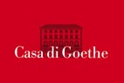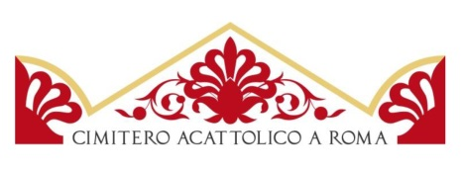

At the foot of the Pyramid:

300 years of the cemetery for foreigners in Rome
An exhibition by the Non-Catholic Cemetery in Rome and the Casa di Goethe in Rome
Casa di Goethe
23 September – 13 November 2016

Curated by Nicholas Stanley-Price

On the occasion of the 300th anniversary of one of the most fascinating places in the city, the Non-Catholic Cemetery in Rome and the Casa di Goethe present At the foot of the Pyramid: 300 years of the cemetery for foreigners in Rome.

The exhibition, with important international loans, will remain open to the public at the Casa di Goethe museum from 23 September to 13 November 2016.

This is the first exhibition to reveal how artists have depicted the so-called “Protestant Cemetery”, or “Non-Catholic Cemetery at the Pyramid”, from the 18th to the early 20th centuries. More than forty European and American paintings, drawings and prints on exhibit reflect the extraordinary beauty and intensity of the place, with its towering trees, its gravestones and glimpses of the sky above. At the same time they document the history and gradual transformation of this magical corner in the shade of the Pyramid of Cestius in Rome’s Testaccio quarter.

“The most beautiful and solemn cemetery I have ever beheld” wrote the poet Percy Bysshe Shelley. Ever since the closing years of the Grand Tour non-Catholic foreigners have found eternal rest in front of the pyramid. Among the most famous tombs, some of them designed by artists such as Giovanni Battista Piranesi and Bertel Thorvaldsen, are those of John Keats and Percy Bysshe Shelley, August von Goethe (son of the great poet) and the “beat” poet Gregory Corso. Among Italians we find Dario Bellezza, Carlo Emilio Gadda and Antonio Gramsci.

The area of today’s burial-ground was made available in 1716 by Pope Clement XI and served initially for the burial of members of the Stuart court, in exile from England. Its evocative atmosphere has always attracted numerous painters, but also writers as different as Goethe, Henry James and Gabriele D’Annunzio.

The exhibition shows works by famous artists including J.M.W. Turner, Jacques Sablet, Walter Crane, Jakob Philipp Hackert and Ettore Roesler Franz, Karl Friedrich Schinkel and Edvard Munch. Some are general views of the area near the pyramid, others are of individual graves. Rare depictions of the funeral ceremonies held at night are intriguing illustrations of how Protestant burials were conducted.

The event, curated by Nicholas Stanley-Price, is under the auspices of the fifteen embassies that administer the Cemetery (Australia, Canada, Denmark, Finland, Germany, Greece, Ireland, Netherlands, Norway, Russia, South Africa, Sweden, Switzerland, the United Kingdom and the United States of America), under the Presidency of H.E. Peter McGovern, Ambassador of Canada in Italy.

“We have been fortunate to have obtained loans from various European museums”, said the curator, “as well as others from private collections in Germany, Scandinavia, the UK and the USA. Some of them have never previously been shown in Italy, and never together in one place as here in our exhibition. They are unusual views that convey the fascination that the Cemetery continues to exert even today on those who visit it.

The exhibition catalogue is published in three language-editions (English, Italian and German). “Today the enchanting Non-Catholic Cemetery is a very important place for Romans and foreigners resident in the city. Here numerous artists are buried, while others have described or drawn the cemetery in the shadow of the Pyramid of Cestius. Our contribution to the exhibition “At the foot of the Pyramid” continues a long tradition of support for projects connected with Rome. It reflects the spirit of the founder Ernst von Siemens who wished to promote access to art and culture.” Dr. Martin Hoernes, Secretary-General of the Ernst von Siemens Kunststiftung/Munich (sponsor of the catalogue)

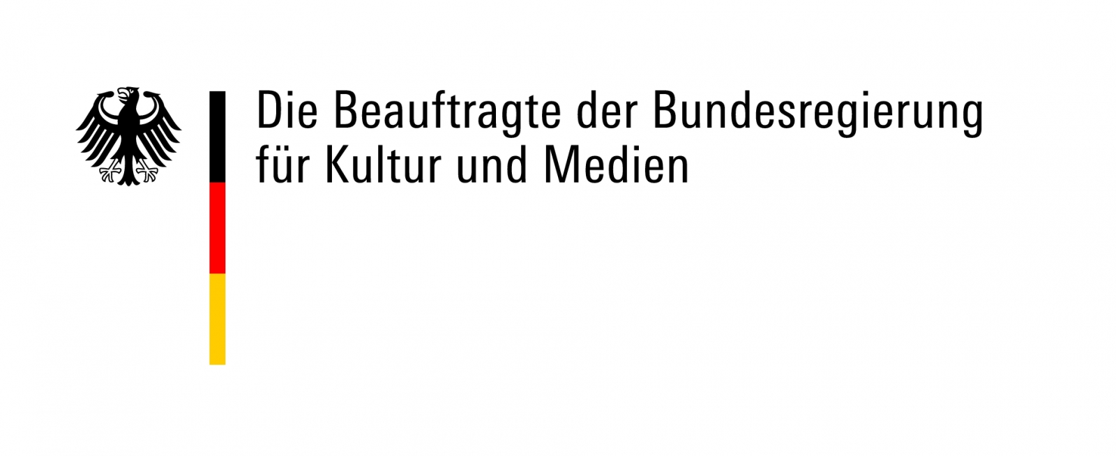

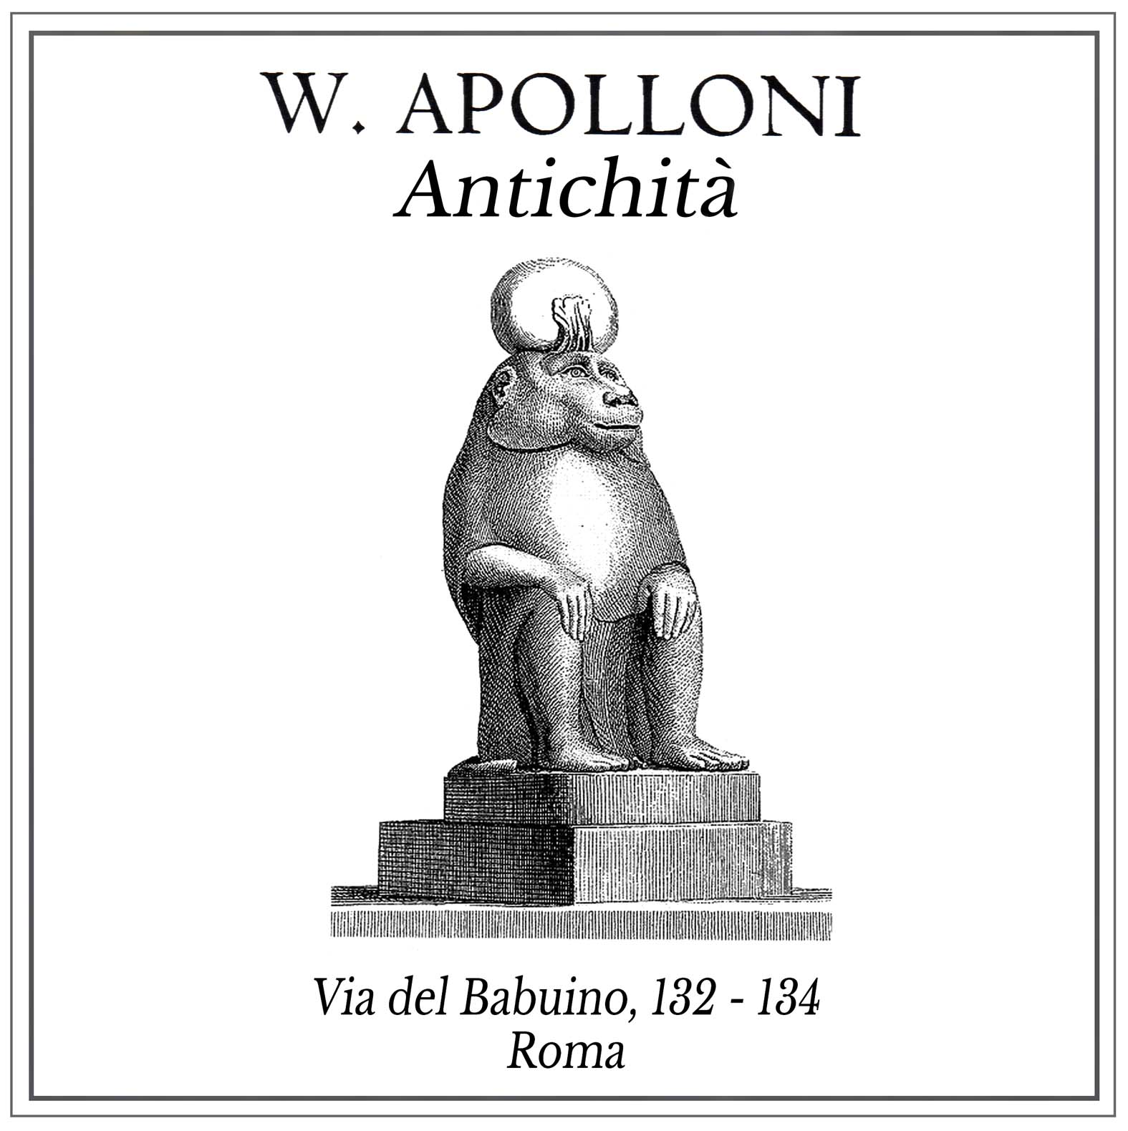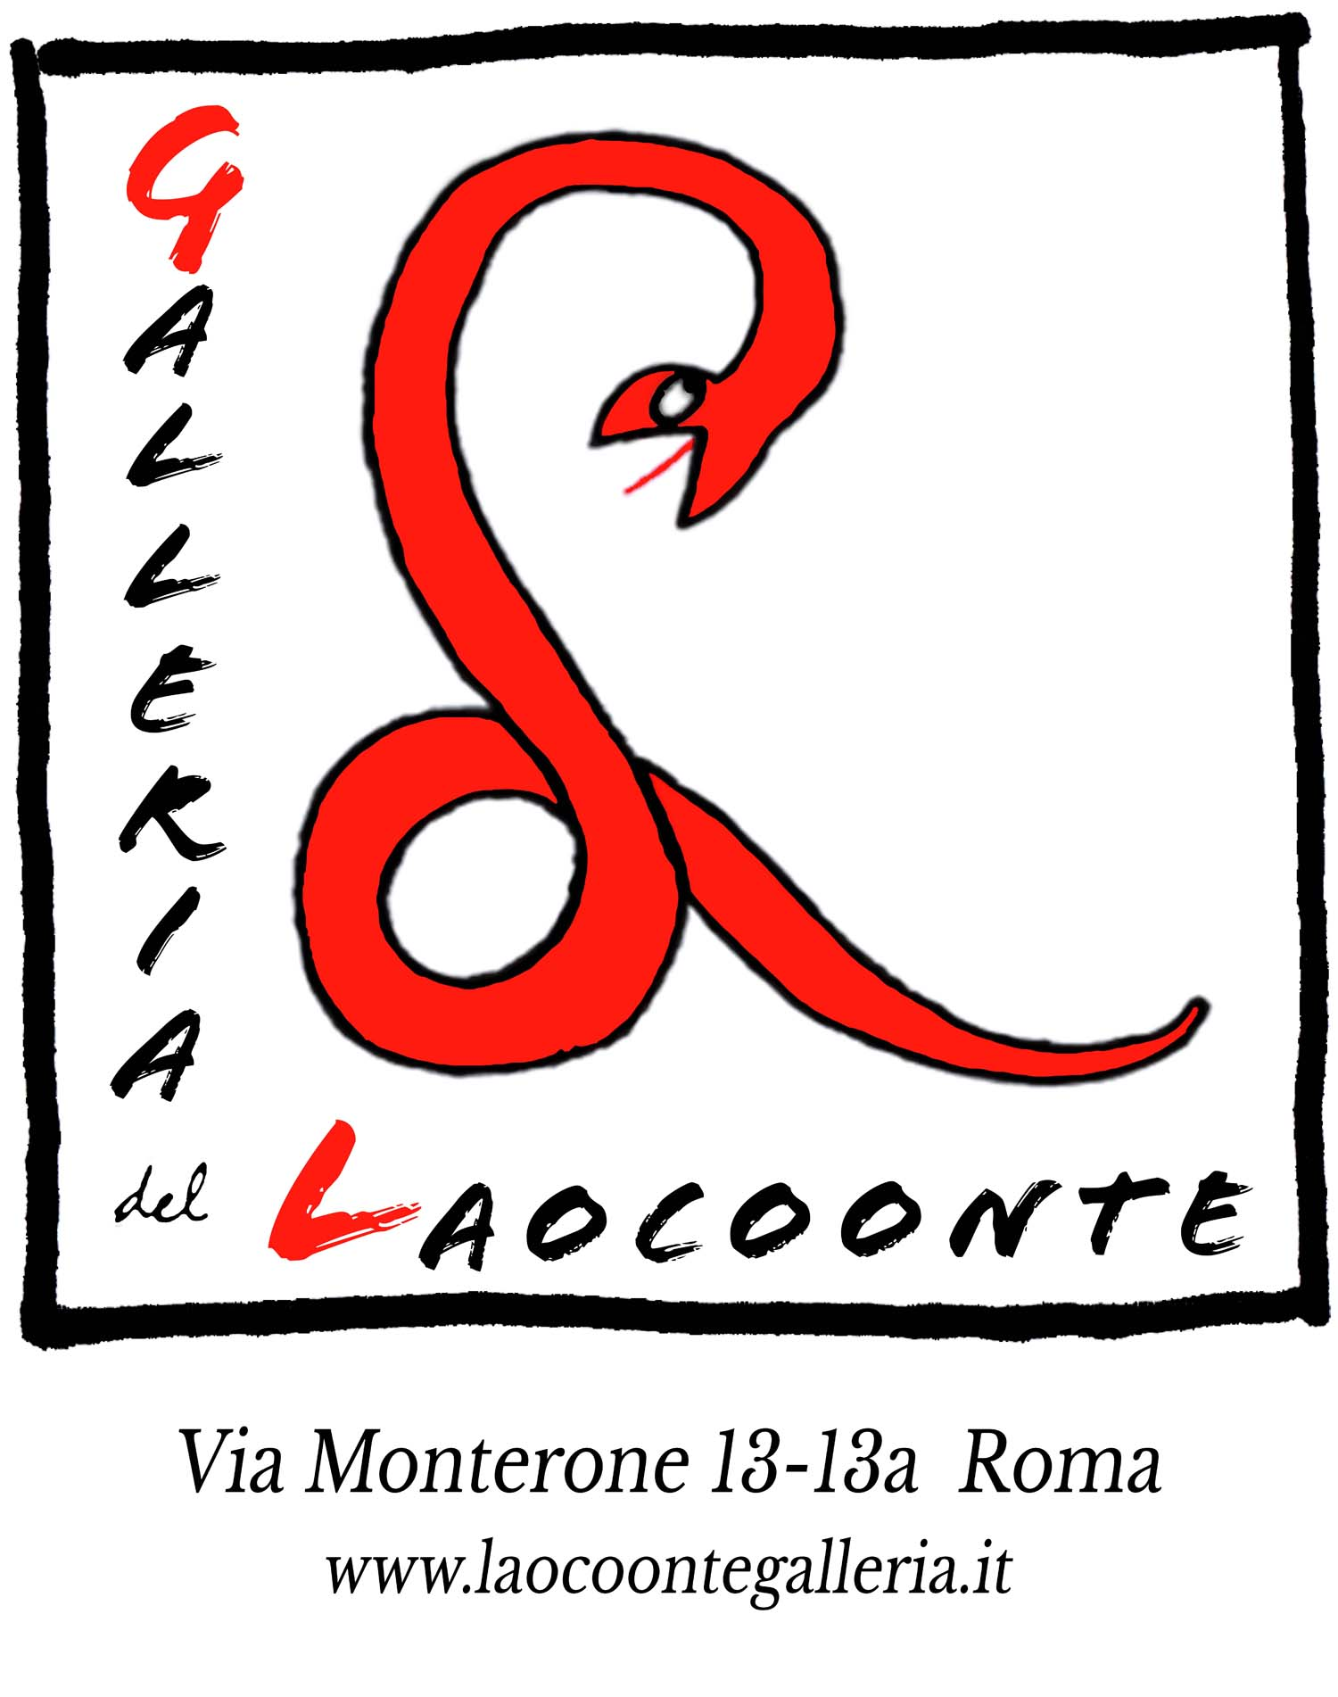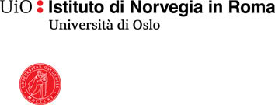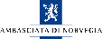
Organisation of the exhibition 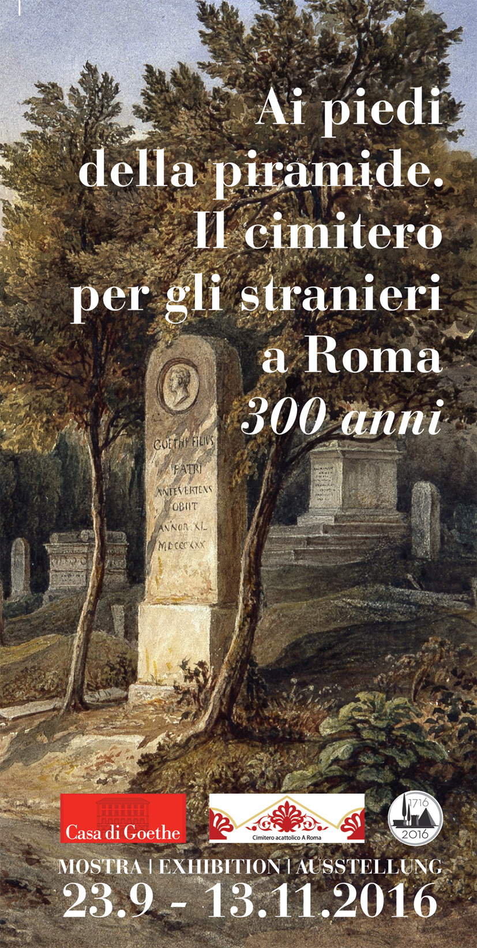

Promoted and organised by: Non-Catholic Cemetery in Rome | Casa di Goethe Rome
With the support of The German Federal Government Commissioner for Culture and the Media and the Arbeitskreis selbständiger Kultur-Institute e.V; and with the collaboration ofthe Embassy of the United States of America to Italy and Pro Helvetia

Exhibition curated by Nicholas Stanley-Price

Sponsors Nicola Bulgari, Galleria W. Apolloni, Galleria del Laocoonte, The Norwegian Institute in Rome, The Royal Embassy of Norway in Rome, Ernst von Siemens Kunststiftung München, Stiftelsen UNI Norway
Legal adviser: EXPLegal Italian and International Law Firm

Exhibition venue Casa di Goethe | Via del Corso 18 (Piazza del Popolo) Rome
Opening-hours, guided visits Daily 10.00-18.00, closed Mondays
Visitors admitted to the exhibition until 30 minutes before closing-time. Guided visits on appointment. On Sundays at 4.00 pm the entrance ticket includes a guided visit in English.

Tickets € 5,00, concessions € 3,00. Family card € 13,00
+39 06 32650412 | www.casadigoethe.it | info@casadigoethe.it

Catalogue At the foot of the Pyramid: 300 years of the cemetery for foreigners in Rome. Edizioni AsKI e.V.|Casa di Goethe/Non-Catholic Cemetery in Rome. Authors: Nicholas Stanley-Price, Mary K. McGuigan and John F. McGuigan Jr. 120 pages, 18.00 Euro. ISBN-13: 978-3-930370-40-5 (English version). On sale at the Casa di Goethe, the Non-Catholic Cemetery in Rome and the Keats Shelley House and through their online shops.

Vernissage Thursday 22 September 2016
from 18.30 to 22.00
with thanks to www.felsina.it for providing wines

Information Non-Catholic Cemetery www.cemeteryrome.it | mail@cemeteryrome.it

Events in the exhibition programme 13 October at 18.30. Lecture by the curator, Nicholas Stanley-Price
29 October, at 17.00. Readings with Mario Fortunato
More information at www.casadigoethe.it

Press office: Dorothee Hock |info@casadigoethe.it | Tel. +39 0632650412 |Cell. 331 7870879

